Name : Manmath Maroti Kornule
Prn : 202401110045
Batch : A3

LAB 8 : Median

Median of two sorted arrays of equal size (Unit 1 self-study tie-in).
Given A = [1, 3, 8, 9, 15] and B = [7, 11, 18, 19, 21], both sorted and of size 5, find the median of the combined set. (a) Solve it once by merging (O(m + n)) and once by the logarithmic divide-and-conquer method. (b) Compare the two approaches' time and space complexity.

Code:
#include <iostream>
#include <algorithm>
#include <iomanip>

using namespace std;

// ============================================================================
// Approach 1: Merge Method (Linear Time - O(m + n))
// ============================================================================
// Uses two pointers to simulate merging the two sorted standard arrays.
// Because m = n, total elements = 2n.
// The median is the average of elements at index (n - 1) and index n
// in the merged sequence.
//
// Time Complexity: O(n) which is O(m + n) since m = n
// Space Complexity: O(1) auxiliary space
// ============================================================================

double findMedianByMerge(const int A[], const int B[], int n) {

int i = 0; // Pointer for array A
int j = 0; // Pointer for array B

int m1 = -1; // Stores element at index (n - 1)
int m2 = -1; // Stores element at index n

// We advance n + 1 times to find elements at rank n and n + 1
for (int count = 0; count <= n; ++count) {
// Shift previous element
m1 = m2;

if (i < n && j < n) {
if (A[i] <= B[j]) {
m2 = A[i++];
} else {
m2 = B[j++];
}
} else if (i < n) {
m2 = A[i++];
} else {
m2 = B[j++];
}
}

return (m1 + m2) / 2.0;
}

// Helper function to find the median of a single sorted standard array
double getArrayMedian(const int arr[], int n) {
if (n % 2 == 0) {
return (arr[n / 2 - 1] + arr[n / 2]) / 2.0;
}
return arr[n / 2];
}

// ============================================================================
// Approach 2: Divide and Conquer Method (Logarithmic Time - O(log n))
// ============================================================================
// Recursively compares the medians m1 and m2 of subarrays of A and B:
// 1. If m1 == m2, return m1.
// 2. If m1 < m2, median lies in A[m1...end] and B[start...m2].
// 3. If m1 > m2, median lies in A[start...m1] and B[m2...end].
//
// Time Complexity: O(log n)
// Space Complexity: O(log n) due to recursive call stack
// ============================================================================

double findMedianDivideAndConquer(const int A[], const int B[], int n) {
// Base Case 1: Subarrays of size 1
if (n == 1) {
return (A[0] + B[0]) / 2.0;
}

// Base Case 2: Subarrays of size 2
// For 4 sorted numbers {A[0], A[1], B[0], B[1]}, the two middle values are:
// max(A[0], B[0]) and min(A[1], B[1])
if (n == 2) {
return (max(A[0], B[0]) + min(A[1], B[1])) / 2.0;
}

double m1 = getArrayMedian(A, n);
double m2 = getArrayMedian(B, n);

// If medians are equal, return immediately

if (m1 == m2) {
return m1;
}

// If m1 < m2, the median must lie in A[m1...] and B[...m2]
if (m1 < m2) {
if (n % 2 == 0) {
// For even n, include the elements contributing to the median

return findMedianDivideAndConquer(A + n / 2 - 1, B, n - n / 2 + 1);
}
return findMedianDivideAndConquer(A + n / 2, B, n - n / 2);
}
// If m1 > m2, the median must lie in A[...m1] and B[m2...]

else {
if (n % 2 == 0) {
return findMedianDivideAndConquer(B + n / 2 - 1, A, n - n / 2 + 1);
}
return findMedianDivideAndConquer(B + n / 2, A, n - n / 2);
}
}

int main() {
// Standard normal C-style arrays
int A[] = {1, 3, 8, 9, 15};
int B[] = {7, 11, 18, 19, 21};
int n = sizeof(A) / sizeof(A[0]);

cout << "==========================================================" << "\n";
cout << " Median of Two Sorted Arrays of Equal Size (n = " << n << ")" << "\n";
cout << "==========================================================" << "\n";

cout << "Array A: ";
for (int i = 0; i < n; ++i) {
cout << A[i] << " ";
}
cout << "\n";

cout << "Array B: ";
for (int i = 0; i < n; ++i) {
cout << B[i] << " ";
}
cout << "\n\n";

cout << fixed << setprecision(2);

// (a) Solution 1: Merging approach O(m + n)
double medianMerge = findMedianByMerge(A, B, n);
cout << "Approach 1 (Merging - O(m + n)): " << medianMerge << "\n";

// (a) Solution 2: Divide and Conquer approach O(log n)
double medianDivideConquer = findMedianDivideAndConquer(A, B, n);
cout << "Approach 2 (Divide & Conquer - O(log n)): " << medianDivideConquer << "\n";

cout << "==========================================================" << "\n";

return 0;
}

OUTPUT:
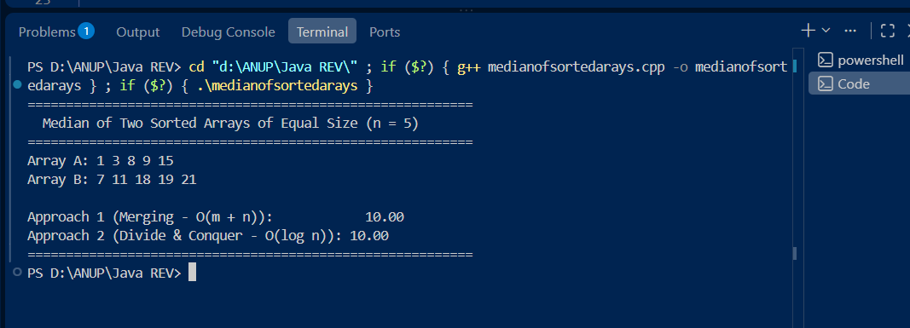

Time and Space Complexity Comparison
The problem can be solved using two different approaches: the Merge Method and the Divide and Conquer Method. Both approaches produce the same median, but their time and space requirements are different.

1. Merge Method
The Merge Method uses two pointers, one for each sorted array. At every step, the smaller element is selected, similar to the merge operation in Merge Sort. Since the arrays contain n elements each, only the elements required to reach the two middle positions need to be processed.

Time Complexity:
$$O\left(n\right)$$
The algorithm processes elements sequentially until it reaches the middle of the combined arrays. Therefore, its running time is linear.

Space Complexity:
$$O\left(1\right)$$
No additional array is created. Only a few variables such as i, j, m1, and m2 are used, so the auxiliary space is constant.

2. Divide and Conquer Method
The Divide and Conquer Method compares the medians of the two sorted arrays. Based on which median is smaller, approximately half of the elements can be eliminated from consideration. The same process is then repeated recursively on the remaining portions.
Time Complexity:
$$O\left(\log{n}\right)$$
At every recursive step, the problem size is approximately reduced by half:
$$n→\frac{n}{2}→\frac{n}{4}→\frac{n}{8}→⋯$$
Therefore, the number of recursive steps is logarithmic.
Space Complexity:
$$O\left(\log{n}\right)$$
The algorithm uses recursion. Since the recursion depth is approximately $\log{n}$, the recursive call stack requires $O\left(\log{n}\right)$auxiliary space.

Comparison Table
Approach | Time Complexity | Space Complexity | Main Idea
Merge Method | $$O\left(n\right)$$ | $$O\left(1\right)$$ | Use two pointers to find the middle elements
Divide and Conquer | $$O\left(\log{n}\right)$$ | $$O\left(\log{n}\right)$$ | Compare medians and eliminate half the elements

Conclusion
The Merge Method is simpler to implement and requires constant auxiliary space, but it takes $O\left(n\right)$time. The Divide and Conquer Method is more efficient in terms of time, achieving $O\left(\log{n}\right)$, but it uses $O\left(\log{n}\right)$space because of recursive calls. Therefore, when time efficiency is the primary requirement, the Divide and Conquer Method is preferable.

